Original padlock | New information or restriction  about the padlock | No.  of codes | Justification about  the count of the total number of codes
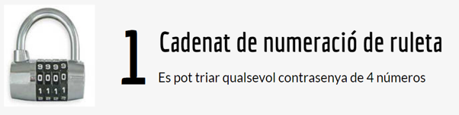 | Padlock 7: Padlock 1 of roulette numbering, from which we know that the password does not contain repeated digits.
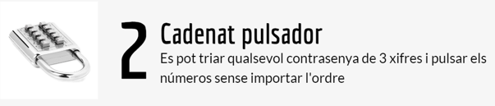 | Padlock 8: 2-button padlock , from what we know for sure the password has 7 digits.
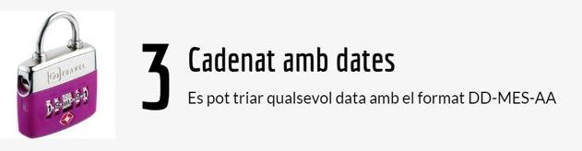 | Padlock 9: Padlock 3 with dates, from what we know that neither the days nor the years contain repeated numbers.
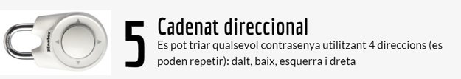 | Padlock 10: 5-way padlock , from what we know the password does not contain repeated directions.
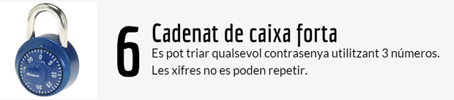 | Padlock 11: Safe padlock 6 , from which we know that the password (3 numbers) has 2 repeated digits.

